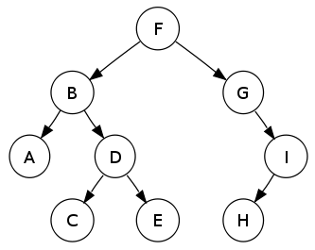
Binary Trees, BST. Normal
- Pre-post-In Traversal. Write code to print pre-, post- and in-order traversal output for the following tree.
- Balanced Tree. Implement a function to check if a tree is balanced. Balanced tree is a tree such that no two leaf nodes differ in distance from the root by more than one.
- Verify BST. Given the root of a binary tree, verify whether or not the tree is a binary search tree.
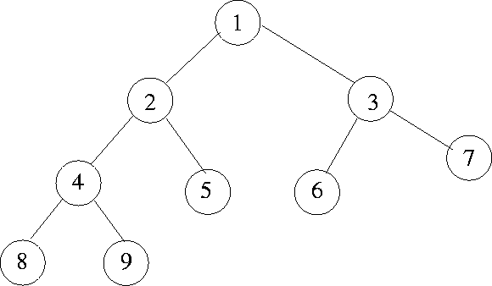
- Breadth First Search. Implement a breadth first search algorithm recursively and iteratively for a binary tree.
- Lowest common ancestor in BT (not BST). Given two values that already exist in a binary tree, find the lowest common ancestor.
Example: For this tree, common ancestor for nodes 8 and 5 is node 2
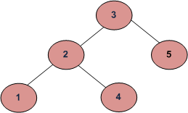
- Get Level of a node in a Binary Tree. Level of a node is distance from root to that node. Given a Binary Tree and a key, write a function that returns level of the key.
Example, consider the following tree. If the input key is 3, then your function should return 0. If the input key is 4, then your function should return 2. And for key which is not present in key, then your function should return -1.
- Finding Kth smallest element in binary search tree. You are given a binary search tree and you are asked to find the Kth smallest element in that tree.

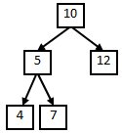
Binary Trees, BST. Advanced
- Verify BST. Given the root of a binary tree, verify whether or not the tree is a binary search tree.
- Paths with Specific Sum in Binary Tree. Given a binary tree and a number, please print out all of paths where the sum of all nodes value is same as the given number.
Example: For instance, if inputs are the binary tree in the given figure and a number 22, two paths with be printed: One is the path contains node 10 and 12, and the other contains 10, 5 and 7.
- Binary Tree with Minimum Height. Given a sorted (increasing order) array, write an algorithm to create a binary tree with minimal height
- Delete Node from BST. Implement a function which delete a node from a binary search tree.
- Linked list from BST. Given a binary search tree, design an algorithm which creates a linked list of all the nodes at each depth (eg, if you have a tree with depth D, you’ll have D linked lists).
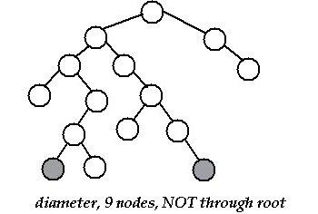
- Create a binary tree from Mathematical Expression. If you are given an infix/postfix expression, make an expression tree out of it. Eg. Convert a postfix expression into an expression tree
- Diameter of a Tree. Find a diameter of a tree which is the longest path between two leaf nodes in a tree.
- Closest Node BST. Given a binary search tree and a value k. Find a node in the binary search tree whose value is closest to k.

Binary Trees, BST. Easy
- Pre-post-In Traversal. Write code to print pre-, post- and in-order traversal output for the following tree.
- Balanced Tree. Implement a function to check if a tree is balanced. Balanced tree is a tree such that no two leaf nodes differ in distance from the root by more than one.
- Get Level of a node in a Binary Tree. Level of a node is distance from root to that node. Given a Binary Tree and a key, write a function that returns level of the key.
Example, consider the following tree. If the input key is 3, then your function should return 0. If the input key is 4, then your function should return 2. And for key which is not present in key, then your function should return -1.
- Verify BST. Given the root of a binary tree, verify whether or not the tree is a binary search tree.
- Breadth First Search. Implement a breadth first search algorithm recursively and iteratively for a binary tree.

